Curriculum for
Diploma Programme in
AIRCRAFT MAINTENANCE ENGINEERING

For the State of Haryana

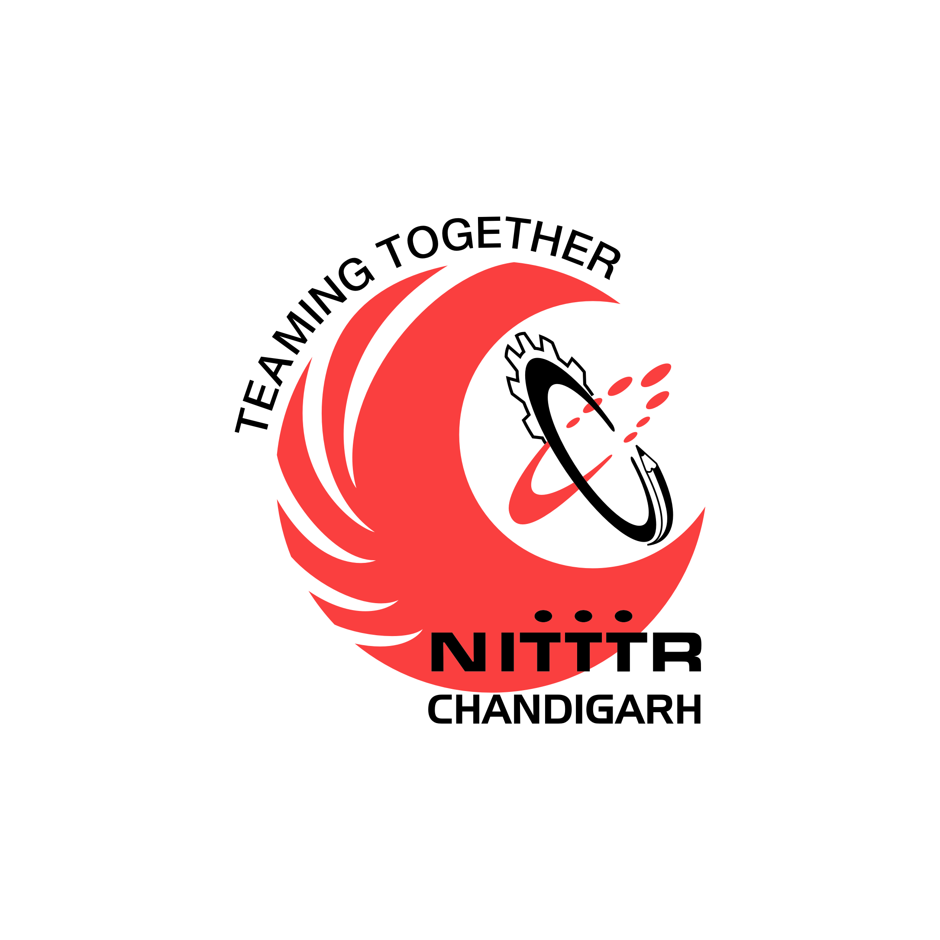

Prepared By:

Curriculum Development Centre

National Institute of

Technical Teachers Training and Research

Sector 26, Chandigarh - 160 019

June, 2015

